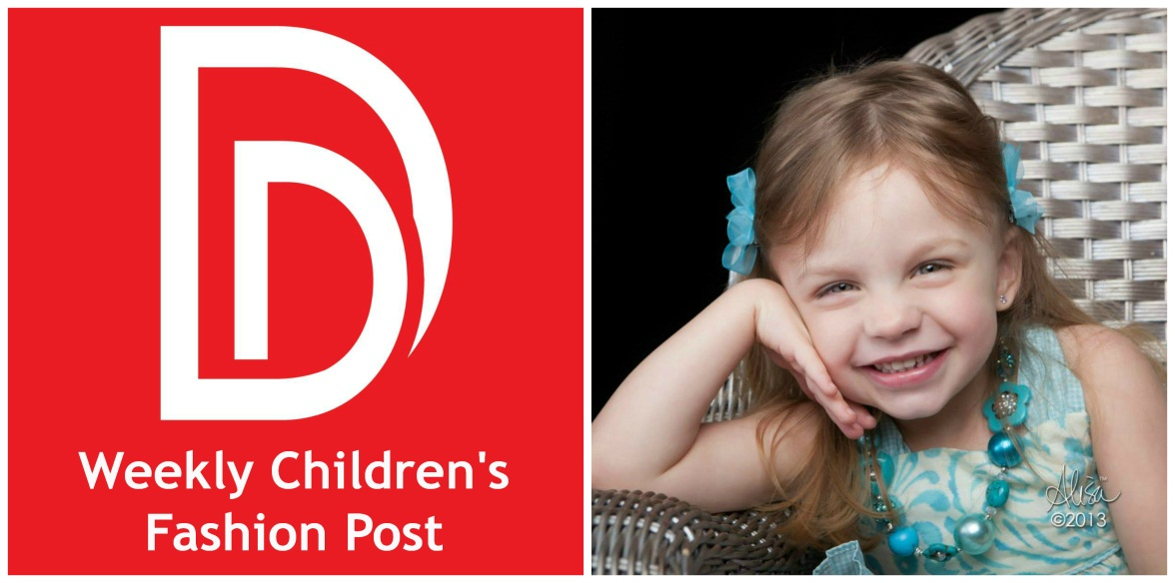
(the above picture would be the feature image for the post)
Hi! Its Denise Murtha from denise designed.
I am so excited to be a weekly fixture here at Alisa Murray’s Through My Lens blog. When I thought about what my first post should be about, I decided it would be helpful to provide a little background, share our partnership and set some expectations.
So a little background about me…
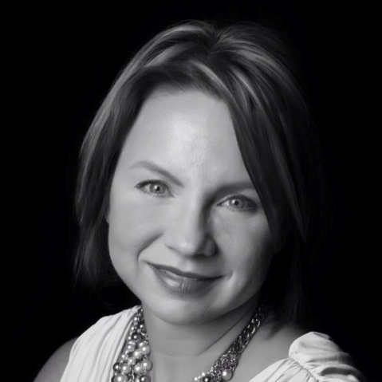
I won’t share all of the boring stuff. Instead, if interested, you can visit my About Me page for the basics. But it is important to note that I was both a fashion merchandising and music major. So I am a bit artsy and love, love, love fashion. I started 2013 in software sales (am still there and plan to be there for awhile) but felt that I needed something more. My focus has always been work and I needed something else to balance better. And I wanted something that I could leverage my creativity and that artsy side. I tried a couple of different blogs and themes and finally landed on denise designed.
Originally the focus for denise designed was home design. But again, you can read more at denise designed. There has definitely been an evolution since its inception and I now write and post on a variety of topics. One topic that I have drafted a post a few different time was Children’s Fashion, but never published them.
Now a little background about my partnership with Alisa Murray…
I met Alisa when my daughter Emma was born. She has been my photographer since then taking annual pictures of Emma and then a few times here and there throughout the year. We quickly became friends, as most people do who frequent the Alisa Murray Photography studio.
As I started down my blog journey, Alisa and I would discuss and share ideas, struggles and goals.
It just seemed a good fit to partner together.
For me, Alisa has been such a great friend and partner that I am honored to be a contributor here.
What can you expect from me:
I will be posting weekly here with Children’s Fashion tips, brand/designer highlights, editorials and lots more!
With my love for fashion, my 4 year old daughter of whom I love to style and Alisa Murray Photography’s focus on children portraits, I hope to provide a lot of valuable and fun content.
If you have any specific interests, comments or need help with anything in particular, you can email me directly at denise@denisedesigned.com.
If you don’t know, Alisa is a contributor on my blog as well. She posts a Photo Tip of the Week. Come and visit regularly, subscribe to the blog or “like” my Facebook page to see those weekly as well.
Thank you and I look forward to seeing you here next week!
A big thank you and lots of hugs to Alisa Murray!!
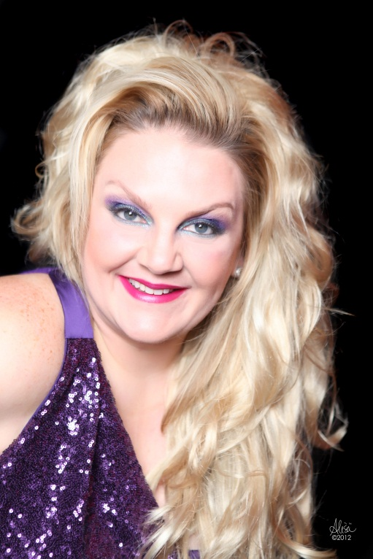
Related Articles…
- Winner I Full Portrait Photo with Well-Renowned Alisa Murray I $250 Value (denisedesigned)
- Welcome Alisa Murray (denisedesigned.com)
- Get to Know Alisa Murray Extraordinaire (denisedesigned.com)
- Giveaway I Full Portrait Photography Session wit Well Renowned Alisa Murray (denisedesigned.com)
- I love Fashion…and that includes Children’s Fashion (denisedesigned.com)

